SIMATS ENGINEERING
ASSESSMENT TOOL 1

COURSE NAME: Database Management Systems
COURSE CODE: CSA0504

COURSE OUTCOME COVERED

CO5: Implement database operations using query processing, optimization, and transaction management to ensure consistency and reliability. (BL3, BL4)

Activity Tool : Constraint-Based Problem Solving (High)
Assessment Tool Weightage:40%

Dr

QUESTIONS
Q.No | Question | Bloom's Level
1 | Given a complex SQL query with nested joins and sub-queries, draw the query execution plan and apply heuristic optimization rules step-by-step. | BL4 – Analyze
2 | Apply cost-based optimization to choose between nested-loop join, sort-merge join, and hash join for the given relations with specified tuple counts and page sizes. | BL4 – Analyze
3 | Implement JDBC connectivity in Java to a MySQL database and write code to execute parameterized queries with PreparedStatement. | BL3 – Apply
4 | Given a schedule of four concurrent transactions, determine whether it is conflict-serializable using a precedence graph. | BL4 – Analyze
5 | Demonstrate the application of Basic Two-Phase Locking (2PL) on a given transaction set. Identify and resolve any deadlocks. | BL3 – Apply
6 | Apply the Wait-Die and Wound-Wait timestamp-based deadlock prevention schemes on a given set of transactions requesting locks. | BL4 – Analyze
7 | Given transaction logs with checkpoints, apply the Immediate Update recovery protocol to recover the database after a system failure. | BL3 – Apply
8 | Apply Deferred Update (NO-UNDO/REDO) recovery technique on a given log file with committed and uncommitted transactions. | BL3 – Apply
9 | Design a concurrency control mechanism using strict 2PL for a banking system where T1 transfers funds and T2 reads balance simultaneously. | BL4 – Analyze
10 | Write pseudocode for query optimization using heuristics: push down selection, project early, and order joins by smaller intermediate results. | BL4 – Analyze

Code of Conduct:

I DARSHINIE KARANI.V.M (192520033) (Name / Reg No) certify that this submission is my original work and that I have adhered to the guidelines specified for this assessment.
I understand that any violation of academic integrity rules will result in disciplinary action.

Signature of the student:

RUBRICS FOR CALCULATION:

Criteria | Weightage | Level 4 (Exemplary) | Level 3 (Proficient) | Level 2 (Developing) | Level 1 (Beginning)
Problem Understanding | 25% | Clearly defines the problem and identifies all relevant constraints accurately | Identifies most constraints with minor gaps | Partial understanding; misses key constraints | Fails to identify constraints correctly
Constraint Analysis | 25% | Analyzes constraints effectively and prioritizes them logically | Provides reasonable analysis with some prioritization | Limited analysis; weak prioritization | No meaningful analysis or prioritization
Solution Development | 25% | Develops optimal and feasible solutions satisfying all constraints | Develops workable solutions with minor limitations | Solutions partially satisfy constraints | Solutions do not meet constraints
Application of Concepts | 15% | Effectively applies appropriate concepts, methods, or tools | Applies concepts with minor errors | Limited application; requires guidance | Unable to apply relevant concepts
Justification | 10% | Provides strong justification for decisions with logical reasoning | Provides justification with some clarity | Weak or unclear justification | No justification provided

1.
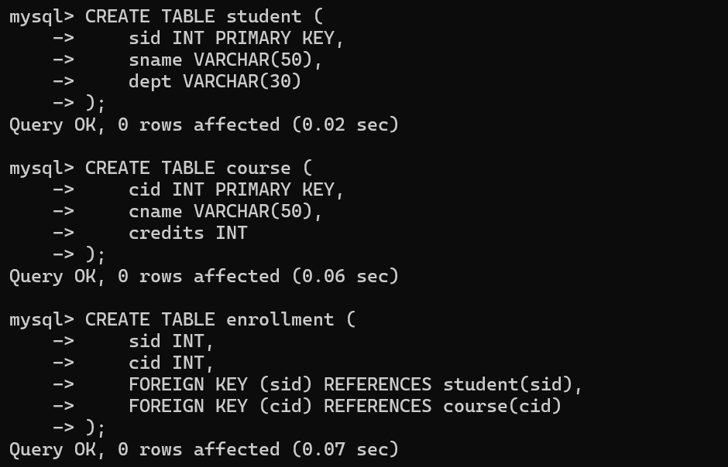
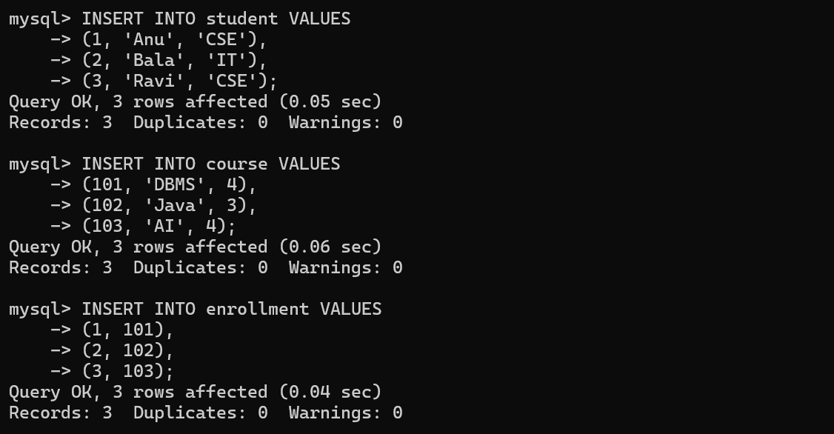
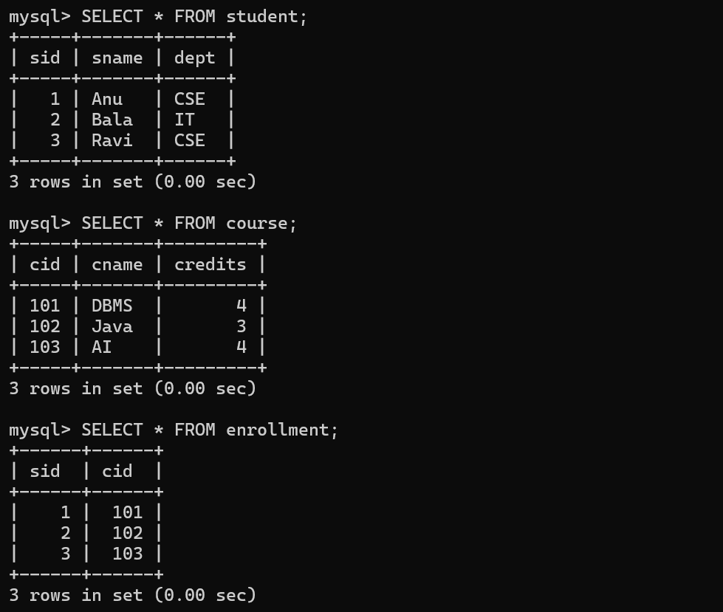
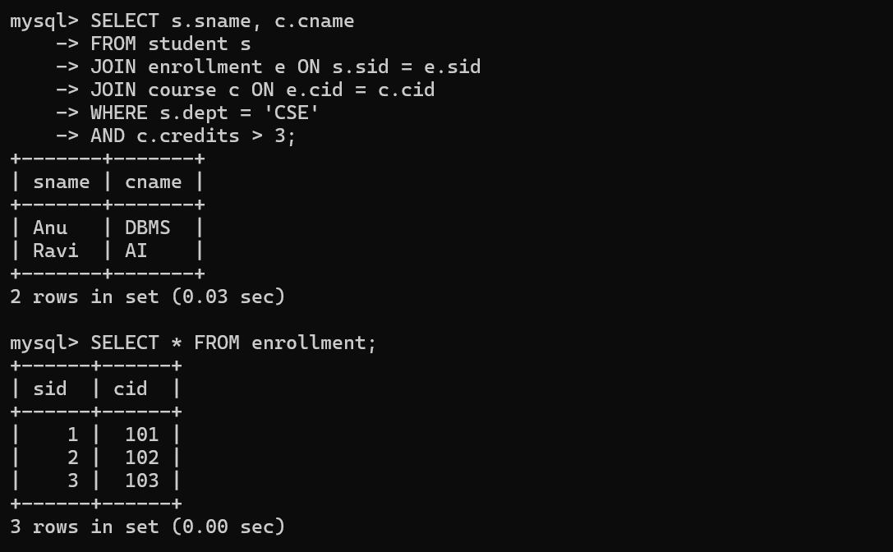

2.
1. Nested-Loop Join
Cost:
Cost = B(R) + B(R) × B(S)
= 100 + (100 × 50)
= 5100 page accesses
Observation: The cost is high because the inner relation may be scanned repeatedly.
2. Sort-Merge Join
Both relations must first be sorted and then merged.
Approximate cost ≈ 2B(R) + 2B(S) + B(R) + B(S)

= 200 + 100 + 100 + 50
= 450 page accesses
Observation: It is useful when the relations are already sorted or when ordered output is required.
3. Hash Join
The smaller relation is used to build the hash table, and the larger relation is scanned.
Approximate cost = 3 × (B(R) + B(S))

= 3 × (100 + 50)
= 450 page accesses
Observation: Hash join is generally efficient for large unsorted relations with equality join conditions.
Comparison
Join Method | Approximate Cost | Result
Nested-Loop Join | 5100 page accesses | High cost
Sort-Merge Join | 450 page accesses | Efficient
Hash Join | 450 page accesses | Efficient

Final Decision
Based on the estimated cost, Hash Join or Sort-Merge Join is preferred over Nested-Loop Join. For an equality-based join on unsorted relations, Hash Join is generally the best choice because it avoids repeated scans and sorting overhead.
Therefore, the optimizer selects Hash Join as the optimal join method for this example.
3.
Java Program:

import java.sql.*;

public class JDBCExample {
public static void main(String[] args) {

String url = "jdbc:mysql://localhost:3306/college_db";
String username = "root";
String password = "your_password";

try {
// Establish connection
Connection con = DriverManager.getConnection(
url, username, password);

System.out.println("Database connected successfully!");

// Parameterized SQL query
String sql = "SELECT * FROM student WHERE department = ?";

// Create PreparedStatement
PreparedStatement pstmt = con.prepareStatement(sql);

// Set parameter
pstmt.setString(1, "CSE");

// Execute query
ResultSet rs = pstmt.executeQuery();

// Display results
while (rs.next()) {
System.out.println(
rs.getInt("student_id") + " " +
rs.getString("name") + " " +
rs.getString("department")
);
}

// Close resources
rs.close();
pstmt.close();
con.close();

} catch (SQLException e) {
System.out.println("Database error: " + e.getMessage());
}
}
}
Explanation
- DriverManager establishes a connection between Java and MySQL.
- Connection connects to the college_db database.
- PreparedStatement executes a parameterized SQL query using ?.
- setString(1, "CSE") supplies the value for the parameter.
- executeQuery() executes the SELECT statement and returns a ResultSet.
- The ResultSet is used to retrieve and display the records.
- Finally, the connection and other resources are closed.
Advantages of PreparedStatement
- Prevents SQL injection.
- Improves security.
- Allows parameters to be supplied dynamically.
- Can improve performance when the same query is executed multiple times.
Result: The Java program successfully connects to MySQL and retrieves student records using a secure parameterized query.
4.
Step 1: Identify Conflicting Operations
Two operations conflict when:
- They belong to different transactions.
- They access the same data item.
- At least one operation is a write.
The conflicts give the following dependencies:
- R1(A) before W2(A) → T1 → T2
- W2(A) before R4(A) → T2 → T4
- R3(B) before W1(B) → T3 → T1
- W1(B) before R2(B) → T1 → T2
- W3(A) before R4(A) → T3 → T4
- R2(B) before W4(B) → T2 → T4
- W1(B) before W4(B) → T1 → T4
Step 2: Construct Precedence Graph
Vertices:
T1, T2, T3, T4
Edges:
T3 → T1
T1 → T2
T3 → T2
T2 → T4
T3 → T4
T1 → T4
A simplified representation is:
T3
/ \
↓ ↓
T1 → T2
\ |
↓ ↓
T4
Step 3: Check for Cycle
The graph contains no cycle.
A possible topological ordering is:
T3 → T1 → T2 → T4
Conclusion
Since the precedence graph is acyclic, the given schedule is conflict-serializable.
Its equivalent serial schedule is:
T3 → T1 → T2 → T4
Thus, the concurrent execution produces the same result as this serial execution.
5.
Basic 2PL has two phases:
- Growing phase: Transaction can acquire locks but cannot release them.
- Shrinking phase: Transaction can release locks but cannot acquire new locks.
A possible execution is:
T1: Lock-X(A)
Read(A)
Write(A)

T2: Lock-X(B)
Read(B)
Write(B)

T1: Request Lock-X(B) → WAIT
T2: Request Lock-X(A) → WAIT

Identify Deadlock
The situation becomes:
T1 holds lock on A → waiting for B
T2 holds lock on B → waiting for A
Wait-for graph:
T1 → T2
↑ ↓
└─────┘
There is a cycle, so a deadlock exists.

Resolve the Deadlock
One transaction can be selected as the victim and rolled back.
For example:
Abort T2
↓
Release lock on B
↓
T1 obtains lock on B
↓
T1 completes
↓
Restart T2

Final Execution
T1: Lock-X(A)
Read(A)
Write(A)
Lock-X(B)
Read(B)
Write(B)
Commit
Unlock(A), Unlock(B)

T2: Lock-X(B)
Read(B)
Write(B)
Lock-X(A)
Read(A)
Write(A)
Commit

Conclusion
Basic 2PL ensures conflict-serializable schedules by separating lock acquisition and release into growing and shrinking phases. In this example, a deadlock occurred because T1 waited for B while T2 waited for A. The deadlock was resolved by aborting T2, releasing its locks, and allowing T1 to complete.
6.
Since the question paper does not provide a specific transaction set, consider the following example.

Given
Assume three transactions with timestamps:
- T1 = 10 → oldest
- T2 = 20
- T3 = 30 → youngest
Here, a smaller timestamp means the transaction is older.
Suppose:
- T1 holds lock on A
- T2 requests A
- T2 holds lock on B
- T3 requests B

1. Wait-Die Scheme
Rule:
- If the requesting transaction is older than the transaction holding the lock → WAIT
- If the requesting transaction is younger → DIE (abort)

Applying the rule:
T2 requests A, which is held by T1.
T2 (20) → T1 (10)
T2 is younger than T1.
Therefore:
T2 dies/aborts.
Now, T3 requests B, which is held by T2.
Since T2 has already aborted, B is released and T3 can acquire the lock.

2. Wound-Wait Scheme
Rule:
- If the requesting transaction is older → it wounds/aborts the younger transaction holding the lock.
- If the requesting transaction is younger → it waits.
Suppose T1 requests B, which is held by T2.
T1 (10) → T2 (20)
T1 is older than T2.
Therefore:
T1 wounds T2 → T2 is aborted.
T1 then obtains the lock on B.
If T3 requests A, which is held by T1:
T3 (30) → T1 (10)
T3 is younger than T1.
Therefore:
T3 waits.

Comparison
Scheme | Older requests younger's lock | Younger requests older's lock
Wait-Die | Wait | Abort (Die)
Wound-Wait | Abort younger (Wound) | Wait

Conclusion
Both Wait-Die and Wound-Wait prevent deadlocks by using transaction timestamps.
- Wait-Die: Older transactions are allowed to wait, while younger transactions are aborted.
- Wound-Wait: Older transactions can abort younger transactions, while younger transactions wait.
Thus, neither scheme allows a circular wait, preventing deadlock.
7.
Immediate Update is a recovery technique in which database changes made by a transaction can be written to the database before the transaction commits. Therefore, after a system failure:
- Committed transactions → REDO
- Uncommitted transactions → UNDO
A checkpoint reduces the amount of log that must be examined during recovery.

Given Transaction Log
Consider the following log:
<START T1>
<T1, A, 100, 150>
<START T2>
<T2, B, 200, 250>
<COMMIT T1>
<CHECKPOINT>
<T2, C, 300, 350>
<START T3>
<T3, D, 400, 450>
SYSTEM FAILURE

Here:
- T1 committed before the failure.
- T2 was active at the time of failure.
- T3 was also active at the time of failure.

Step 1: Identify Transaction Status
Transaction | Status at Failure | Action
T1 | Committed | REDO
T2 | Uncommitted | UNDO
T3 | Uncommitted | UNDO

Step 2: REDO Committed Transaction
Since T1 committed, its changes must be retained.
REDO T1
A = 150
Therefore, the final value of A = 150.

Step 3: UNDO Uncommitted Transactions
T2 and T3 did not commit before the failure.
For T2:
<T2, C, 300, 350>
Undo the change:
C = 300
Also restore B to its old value:
B = 200
For T3:
<T3, D, 400, 450>
Undo the change:
D = 400

Step 4: Final Database State
After recovery:
A = 150 ← T1 retained
B = 200 ← T2 undone
C = 300 ← T2 undone
D = 400 ← T3 undone

Role of Checkpoint
The checkpoint indicates a known recovery point in the log. During recovery, the system can use the checkpoint to avoid unnecessarily processing older log records, thereby reducing recovery time.

Conclusion
Using the Immediate Update recovery protocol, T1 is REDO because it committed, while T2 and T3 are UNDO because they were uncommitted at the time of failure. The checkpoint helps the DBMS perform recovery more efficiently and ensures that the database returns to a consistent state.
8.

Introduction
Deferred Update is a recovery technique in which the updates made by a transaction are not written to the database until the transaction reaches the commit point.
Therefore, when a system failure occurs:
- Committed transactions are REDO
- Uncommitted transactions are ignored
- UNDO is not required

Given Log
Consider the following log:
<START T1>
<T1, A, 100, 150>
<START T2>
<T2, B, 200, 250>
<COMMIT T1>
<START T3>
<T3, C, 300, 350>
<SYSTEM FAILURE>

Step 1: Identify Transaction Status
At the time of failure:
- T1 → Committed
- T2 → Uncommitted
- T3 → Uncommitted

Step 2: Apply Deferred Update
According to the NO-UNDO/REDO technique, only committed transactions need to be processed.

T1
T1 has committed:
<T1, A, 100, 150>
Therefore, perform REDO(T1):
A = 150

T2
T2 has not committed.
Therefore:
T2 → No action
Its update to B is not applied to the database.

T3
T3 has not committed.
Therefore:
T3 → No action
Its update to C is not applied to the database.

Recovery Table
Transaction | Status | Recovery Action
T1 | Committed | REDO
T2 | Uncommitted | No action
T3 | Uncommitted | No action

Conclusion
The Deferred Update (NO-UNDO/REDO) technique simplifies recovery because uncommitted transactions never need to be undone. After a system failure, the recovery manager only redoes the updates of committed transactions, while updates belonging to uncommitted transactions are ignored. Thus, the database is restored to a consistent state.
9.
Consider two transactions:
- T1: Transfers ₹5,000 from Account A to Account B.
- T2: Reads the balance of Account A and Account B.
The main requirement is that T2 should not read partially updated or inconsistent data while T1 is transferring the money.
Transaction T1 – Fund Transfer
T1:
LOCK-X(A)
LOCK-X(B)

READ(A)
A = A - 5000

READ(B)
B = B + 5000

WRITE(A)
WRITE(B)

COMMIT
UNLOCK(A)
UNLOCK(B)
Transaction T2 – Read Balance
T2:
LOCK-S(A)
LOCK-S(B)

READ(A)
READ(B)

COMMIT
UNLOCK(A)
UNLOCK(B)
Execution
Suppose T1 starts first:
T1: LOCK-X(A)
T1: LOCK-X(B)
T1: Read(A)
T1: A = A - 5000
T1: Read(B)
T1: B = B + 5000
T1: Write(A)
T1: Write(B)

T2: LOCK-S(A) → WAIT
T2: LOCK-S(B) → WAIT

T1: COMMIT
T1: UNLOCK(A)
T1: UNLOCK(B)

T2: LOCK-S(A)
T2: LOCK-S(B)
T2: Read(A)
T2: Read(B)
T2: COMMIT
T2: UNLOCK(A)
T2: UNLOCK(B)
Why T2 Has to Wait
T1 holds exclusive locks (X-locks) on both accounts while performing the transfer.
Therefore, T2 cannot obtain shared locks (S-locks) until T1 commits.
This prevents T2 from seeing a situation where ₹5,000 has been deducted from A but not yet added to B.
Strict 2PL Properties
- Exclusive locks are held until commit or abort.
- T2 cannot read data modified by T1 before T1 commits.
- Dirty reads are prevented.
- The transfer remains atomic and consistent.
- The schedule is conflict-serializable.

Conclusion
Strict 2PL provides safe concurrency control for the banking system. T1 obtains exclusive locks on both accounts and holds them until commit. T2 waits until T1 completes and releases the locks, after which T2 reads the updated balances. Thus, inconsistent and dirty reads are prevented while maintaining database consistency.
10.
Heuristic query optimization improves query performance by transforming the query into an equivalent form that requires fewer intermediate tuples and less processing.
The main heuristics used are:
- Push selections down as close as possible to the base relations.
- Perform projections early to eliminate unnecessary attributes.
- Order joins so that smaller intermediate relations are processed first.

Pseudocode
Algorithm Heuristic_Query_Optimization(Query)
Input:
A relational algebra query containing selections, projections and joins
Output:
Optimized query execution plan
Begin
Step 1: Push Selection Down
For each selection condition σ in Query:
Move σ as close as possible to
the base relation on which it applies.
Step 2: Perform Projection Early
For each relation:
Identify only the attributes required
by selections, joins and final output.
Remove unnecessary attributes using π.
Step 3: Order Joins
Identify all join operations.
Estimate the size of each intermediate relation.
Perform the join involving the smallest
intermediate relation first.
Step 4: Generate Optimized Plan
Combine the modified selections,
projections and joins.
Step 5: Return the optimized execution plan.
End

Example,
Consider:
SELECT S.name, C.course_name
FROM Student S
JOIN Enrollment E
ON S.student_id = E.student_id
JOIN Course C
ON E.course_id = C.course_id
WHERE S.department = 'CSE'
AND C.credits >= 3;

Applying the Heuristics
Step 1 – Selection Push-Down
σ department='CSE' (Student)
σ credits>=3 (Course)
The selections are performed before the joins, reducing the number of tuples.
Step 2 – Early Projection
Keep only the attributes required for the joins and final result:
Student → student_id, name
Enrollment → student_id, course_id
Course → course_id, course_name
Step 3 – Join Ordering
Perform the join that produces the smaller intermediate result first.
Filtered Student
↓
JOIN
↓
Enrollment
↓
JOIN
↓
Filtered Course

Advantages
- Reduces the number of tuples processed.
- Reduces the size of intermediate relations.
- Reduces memory and disk I/O.
- Makes join operations faster.
- Improves overall query execution time.

Conclusion
Heuristic query optimization produces an efficient execution plan by pushing selections down, applying projections early, and performing joins in an order that minimizes intermediate results. These transformations improve query performance without changing the final result.

